Self-service password reset in Azure?

Azure Active Directory (Azure AD) self-service password reset (SSPR) gives users the ability to change or reset their password, with no administrator or help desk involvement. If Azure AD locks a user's account or they forget their password, they can follow prompts to unblock themselves and get back to work.

Enable self-service password reset
Azure AD lets you enable SSPR for None, Selected, or All users. This granular ability lets you choose a subset of users to test the SSPR registration process and workflow. When you're comfortable with the process and the time is right to communicate the requirements with a broader set of users, you can select a group of users to enable for SSPR. Or, you can enable SSPR for everyone in the Azure AD tenant.
Note
Currently, you can only enable one Azure AD group for SSPR using the Azure portal. As part of a wider deployment of SSPR, Azure AD supports nested groups.
Steps:
Sign in to the Azure portal using an account with global administrator or authentication policy administrator permissions.
Search for and select Azure Active Directory, then select Password reset from the menu on the left side.
From the Properties page, under the option Self service password reset enabled, choose Selected.
If your group isn't visible, choose No groups selected, browse for and select your Azure AD group, like SSPR-Test-Group, and then choose Select.
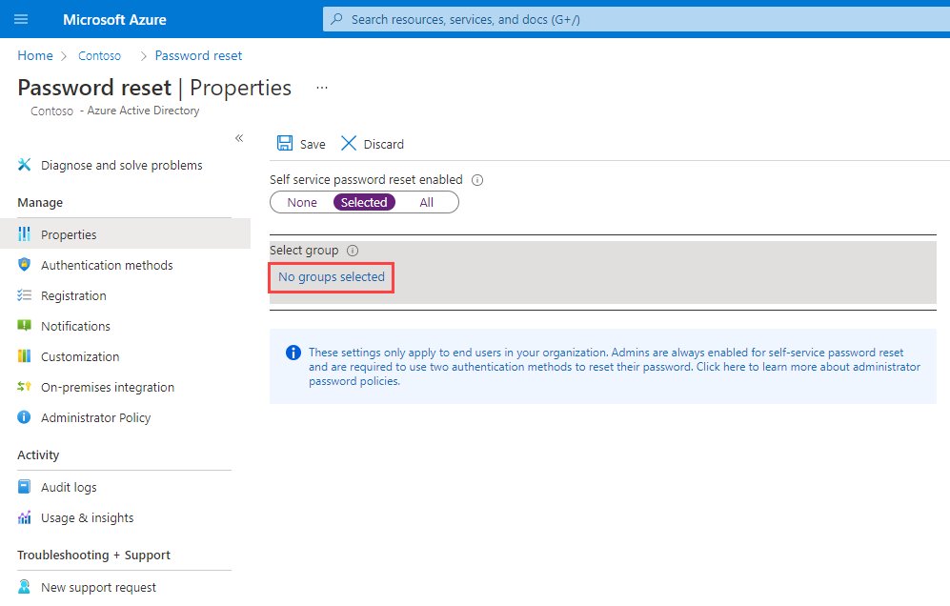
To enable SSPR for the select users, select Save.

Conditional access policy in azure?

Conditional Access policies at their simplest are if-then statements, if a user wants to access a resource, then they must complete an action. Example: A payroll manager wants to access the payroll application and is required to do multifactor authentication to access it.
Administrators are faced with two primary goals:
Empower users to be productive wherever and whenever
Protect the organization's assets
Use Conditional Access policies to apply the right access controls when needed to keep your organization secure.

